Step 1: Generate a Private Key

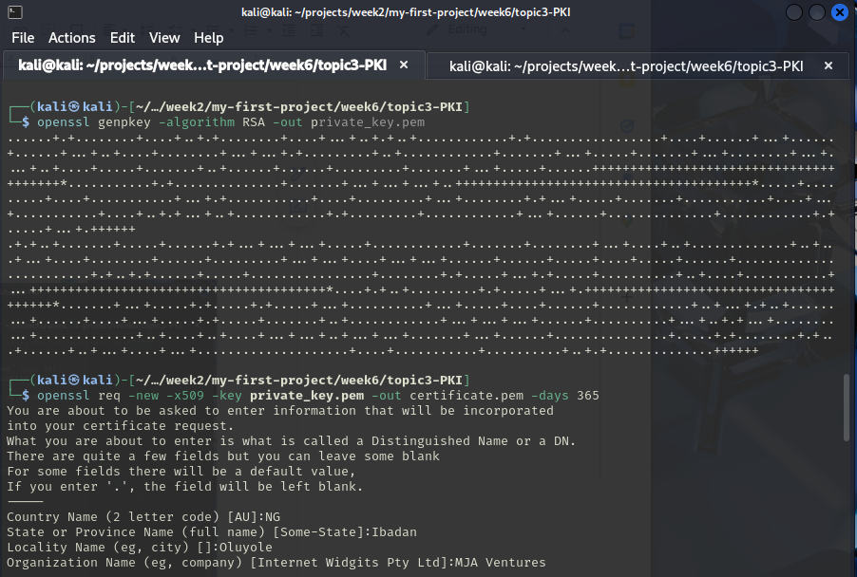

Step 2: Generate a Self-Signed Certificate and then Extract the Public Key.

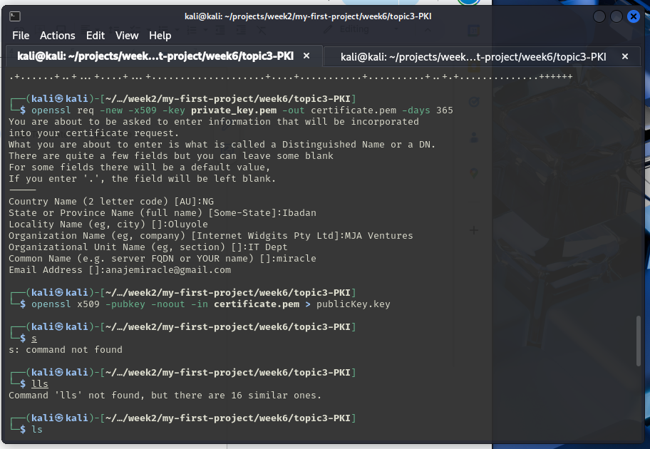

Step 3: Encrypt a Message

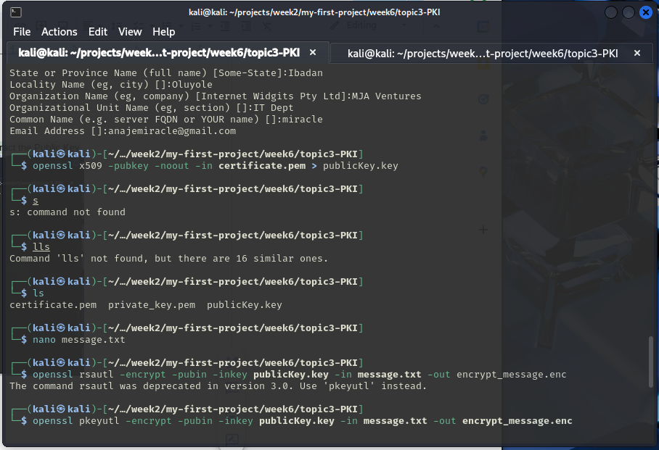

Step 4: Decrypt the Message

